|  |
| --- |
| EPAM Systems, RD Dep. |
| Extraction |

|  |  |  |  |  |  |
| --- | --- | --- | --- | --- | --- |
| REVISION HISTORY | | | | | |
| Ver. | Description of Change | Author | Date | Approved | |
| Name | Effective Date |
| 1.0 | Initial status | Arina Marchenko | 4-DEC-2017 |  |  |

Contents

1. Fact Table 3

# Fact Table

For dm I have one fact table, which is there:

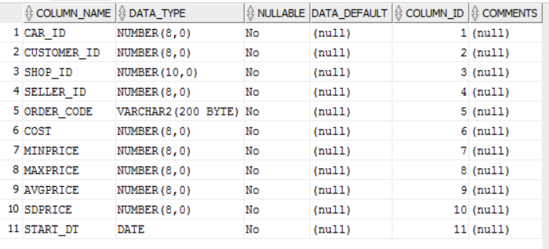

For loading we don’t use merge, only insert

CREATE OR REPLACE PACKAGE BODY pkg_etl_load_cl_tables

AS

PROCEDURE load_cl_dim_cars

IS

BEGIN

DECLARE

CURSOR c_data IS

SELECT c.car_id,

c.car_number,

c.car_name,

vt.vehicle_type_name,

et.engine_type_name,

gt.gearbox_type_name,

m.model_name,

rs.repaired_status_name,

c.start_dt,

c.end_dt

FROM bl_3nf.ce_cars c

left join bl_3nf.ce_vehicle_type vt on c.vehicle_type_id = vt.vehicle_type_id

left join bl_3nf.ce_engine_type et on c.engine_type_id=et.engine_type_id

left join bl_3nf.ce_gearbox_type gt on c.gearbox_type_id = gt.gearbox_type_id

left join bl_3nf.ce_model m on c.model_id=m.model_id

left join bl_3nf.ce_repaired_status rs on c.repaired_status_id = rs.repaired_status_id;

TYPE fetch_array IS TABLE OF c_data%ROWTYPE ;

s_array fetch_array;

BEGIN

OPEN c_data;

LOOP

FETCH c_data BULK COLLECT INTO s_array;

FORALL i IN 1..s_array.COUNT

INSERT INTO fct_sales

VALUES s_array(i) ;

EXIT WHEN c_data%NOTFOUND;

END LOOP;

CLOSE c_data;

COMMIT;

END load_cl_dim_cars;

